Tourism in the US
New territory: Rising inbound trips by non-US residents will increase industry demand

Industry Definition

Tourism is defined as visitors spending during travel primarily for business, convention or conference travel, government business, and the more familiar tourism for leisure, vacation or to visit friends and relatives. Major industries that benefit from tourism expenditure include domestic and international air transportation, accommodation services, food services, drinking places, automotive rental and travel agencies.
Back to top

Major Players
Delta Air Lines Inc. |  | Marriott International Inc.
American Airlines Group Inc. |  | Hilton Worldwide Holdings Inc.
The Walt Disney Company
Back to top

Main Activities

The Primary activities of this industry are:
Accommodation services |  | Food services and drinking place services
Domestic airline operation |  | Automotive rental
International airline operation |  | Travel agent and tour arrangement services

The major products and services in this industry are:
Accommodations |  | Food service and drinking places
Transportation |  | Recreation and entertainment
Back to top

Similar Industries
48111a - International Airlines  This industry provides air transportation abroad for passengers and cargo over regular routes and schedules |  | 71311 - Amusement Parks  Companies in this industry operate various attractions, including theme parks.
48111b - Domestic Airlines  This industry provides local air transportation for passengers and cargo over regular routes and schedules |  | 72111 - Hotels & Motels  This industry provides accommodations for travelers.
56151 - Travel Agencies  This industry provides travel, tours, accommodation planning and booking services. |  | 72112 - Casino Hotels  This industry operates locations that provide accommodations and house casinos.
56152 - Tour Operators
Businesses in this industry plan, package, market and sell multiple vacation elements.
Back to top

Additional Resources
www.bea.gov  US Bureau of Economic Analysis |  | www.visittheusa.com  BrandUSA
www.census.gov  US Census Bureau |  | tinet.ita.doc.gov  National Travel and Tourism Office
www.unwto.org
UN World Tourism Organization
Back to top

Industry Jargon
BRICK AND MORTAR
A store that has a physical presence and location, as opposed to an online retailer.
GLOBAL DISTRIBUTION SYSTEM
A computerized system for agents that comprises details on international and domestic travel product.
REVENUE PER AVAILABLE ROOM (REVPAR)
A measurement that is calculated by multiplying a hotel's average daily room rate (ADR) by its occupancy rate.
STAR ALLIANCE NETWORK
The world's first and largest airline alliance, with agreements between participating airlines to cooperate on a substantial level.
Back to top

Glossary
BARRIERS TO ENTRY
High barriers to entry mean that new companies struggle to enter an industry, while low barriers mean it is easy for new companies to enter an industry.
CAPITAL INTENSITY
Compares the amount of money spent on capital (plant, machinery and equipment) with that spent on labor. IBISWorld uses the ratio of depreciation to wages as a proxy for capital intensity. High capital intensity is more than $0.333 of capital to $1 of labor; medium is $0.125 to $0.333 of capital to $1 of labor; low is less than $0.125 of capital for every $1 of labor.
CONSTANT PRICES
The dollar figures in the Key Statistics table, including forecasts, are adjusted for inflation using the current year (i.e. year published) as the base year. This removes the impact of changes in the purchasing power of the dollar, leaving only the "real" growth or decline in industry metrics. The inflation adjustments in IBISWorld’s reports are made using the US Bureau of Economic Analysis’ implicit GDP price deflator.
DOMESTIC DEMAND
Spending on industry goods and services within the United States, regardless of their country of origin. It is derived by adding imports to industry revenue, and then subtracting exports.
EMPLOYMENT
The number of permanent, part-time, temporary and seasonal employees, working proprietors, partners, managers and executives within the industry.
ENTERPRISE
A division that is separately managed and keeps management accounts. Each enterprise consists of one or more establishments that are under common ownership or control.
ESTABLISHMENT
The smallest type of accounting unit within an enterprise, an establishment is a single physical location where business is conducted or where services or industrial operations are performed. Multiple establishments under common control make up an enterprise.
EXPORTS
Total value of industry goods and services sold by US companies to customers abroad.
IMPORTS
Total value of industry goods and services brought in from foreign countries to be sold in the United States.
INDUSTRY CONCENTRATION
An indicator of the dominance of the top four players in an industry. Concentration is considered high if the top players account for more than 70% of industry revenue. Medium is 40% to 70% of industry revenue. Low is less than 40%.
INDUSTRY REVENUE
The total sales of industry goods and services (exclusive of excise and sales tax); subsidies on production; all other operating income from outside the firm (such as commission income, repair and service income, and rent, leasing and hiring income); and capital work done by rental or lease. Receipts from interest royalties, dividends and the sale of fixed tangible assets are excluded.
INDUSTRY VALUE ADDED (IVA)
The market value of goods and services produced by the industry minus the cost of goods and services used in production. IVA is also described as the industry's contribution to GDP, or profit plus wages and depreciation.
INTERNATIONAL TRADE
The level of international trade is determined by ratios of exports to revenue and imports to domestic demand. For exports/revenue: low is less than 5%, medium is 5% to 20%, and high is more than 20%. Imports/domestic demand: low is less than 5%, medium is 5% to 35%, and high is more than 35%.
LIFE CYCLE
All industries go through periods of growth, maturity and decline. IBISWorld determines an industry's life cycle by considering its growth rate (measured by IVA) compared with GDP; the growth rate of the number of establishments; the amount of change the industry's products are undergoing; the rate of technological change; and the level of customer acceptance of industry products and services.
NONEMPLOYING ESTABLISHMENT
Businesses with no paid employment or payroll, also known as nonemployers. These are mostly set up by self-employed individuals.
PROFIT
IBISWorld uses earnings before interest and tax (EBIT) as an indicator of a company’s profitability. It is calculated as revenue minus expenses, excluding interest and tax.
VOLATILITY
The level of volatility is determined by averaging the absolute change in revenue in each of the past five years. Volatility levels: very high is more than ±20%; high volatility is ±10% to ±20%; moderate volatility is ±3% to ±10%; and low volatility is less than ±3%.
WAGES
The gross total wages and salaries of all employees in the industry. The cost of benefits is also included in this figure.
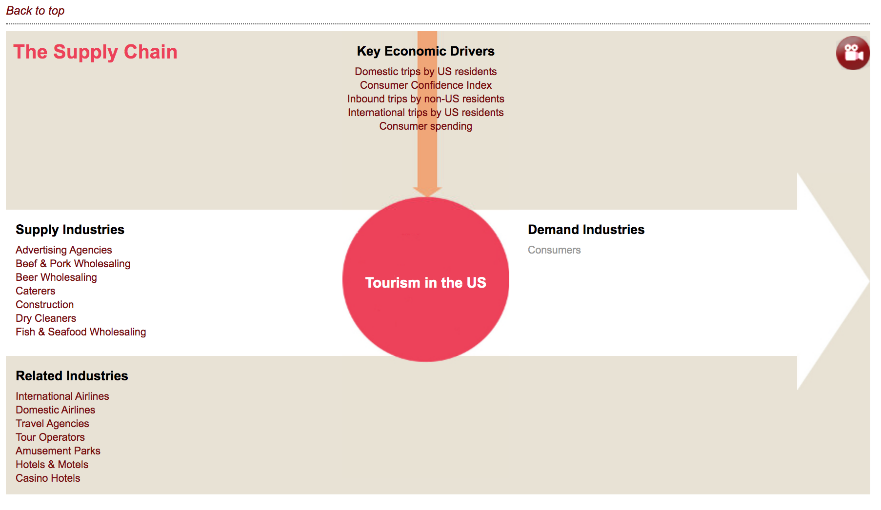

------

Industry Structure
Life Cycle StageMature
Revenue VolatilityLow
Capital IntensityHigh
Industry AssistanceLow
Concentration LevelLow
Regulation LevelLight
Technology ChangeMedium
Barriers to EntryLow
Industry GlobalizationHigh
Competition LevelHigh

Executive Summary
Over the five years to 2018, the Tourism industry has experienced relatively steady growth. However, despite increasing consumer sentiment, declining unemployment and an increase in the number of trips domestic and international travelers were taking in the United States, revenue growth was sluggish early during the period amid heightened competition and unstable commodity markets. Nevertheless, consumer spending continued to increase over the past five years, due to rising disposable incomes and positive consumer sentiment, benefiting industry operators. Therefore, over the five years to 2018, IBISWorld expects industry revenue will increase at an annualized rate of 1.0% to $970.2 billion, including an estimated growth of 2.2% in 2018 alone.
The major sources of industry revenue include traveler accommodations (which are expected to account for 20.0% of industry revenue in 2018); transportation (41.3%); food and beverage services (14.1%); and recreation, entertainment and shopping (24.5%). These areas are all highly influenced by consumer spending trends. About 70.0% of the Tourism industry's demand is derived from those traveling for leisure (i.e. for purposes such as summer vacations, visiting friends or family and attending sporting events). Business travelers, or those undertaking general business travel and those attending conferences or events, make up the balance of the industry's demand.
Over the five years to 2023, the industry is forecast to experience greater growth and steadier revenue gains. While consumer confidence is projected to decrease over the next five years, inbound trips by non-US residents, domestic trips by US residents and consumer spending are forecast to increase, resulting in increased demand for industry services. Concurrently, the trade-weighted index (TWI), which measures the value of the US dollar compared with its major trading partners, is anticipated to decrease over the next five years, making travel to the United States more attractive to foreign travelers, as it will become relatively more affordable. Therefore, over the five years to 2023, industry revenue is forecast to increase at an annualized rate of 1.3% to $1.0 trillion.
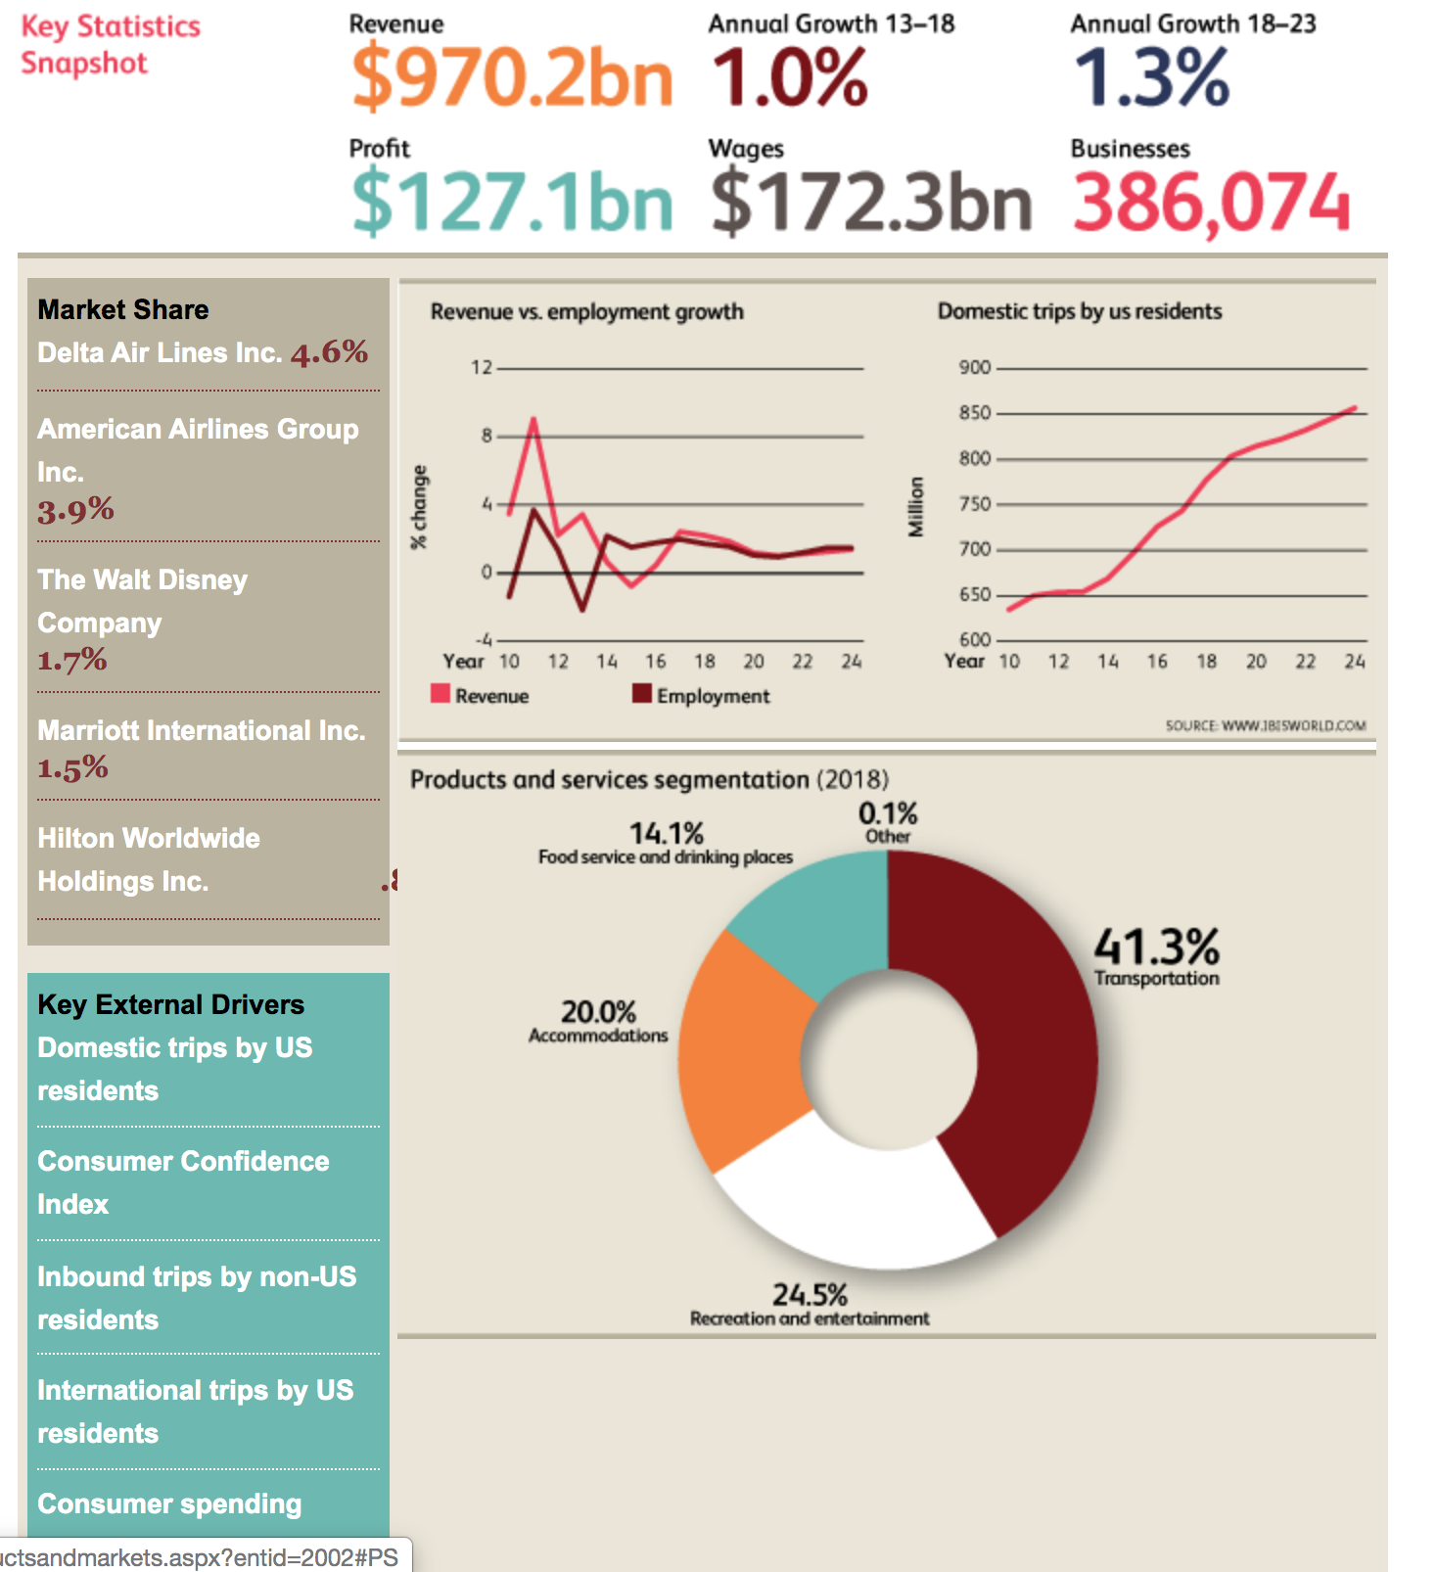

--------------------

Key External Drivers
Domestic trips by US residents
This industry relies on the number of domestic day trips and overnight stays. The more consumers travel domestically, the more likely they are to spend on tourism-related activities. Domestic trips by US residents are expected to increase in 2018, presenting a potential opportunity for the industry.
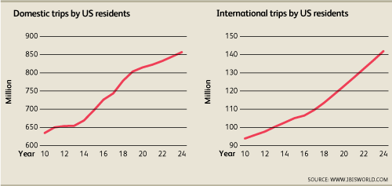
Consumer Confidence Index
The Consumer Confidence Index measures consumers' feelings regarding their current and future financial prospects. Changes in consumer sentiment have a significant influence on travel intentions, demand and expenditure, especially during recessions. When consumers are unsure about their financial prospects, they tend to spend less on discretionary activities such as travel. The Consumer Confidence Index is expected to increase in 2018.
Inbound trips by non-US residents
This industry is sensitive to changes in the number of nights international visitors spend in the United States. The longer a tourist stays in the United States, the more money he or she is likely to spend. Inbound trips by non-US residents are expected to increase in 2018.
International trips by US residents
Outbound US resident travel results in a loss of potential revenue to the local industry due to purchases made overseas. However, some industry segments, such as international airlines and travel agents, may still receive income from bookings. International trips by US residents are expected to increase in 2018, posing a potential threat to the industry.
Consumer spending
Consumer spending measures the total amount Americans spend on services and new goods, both domestically and abroad. When spending levels are high, consumers are more likely to spend on discretionary tourism and travel-related activities. Consumer spending is expected to increase in 2018.
Back to top

Current Performance
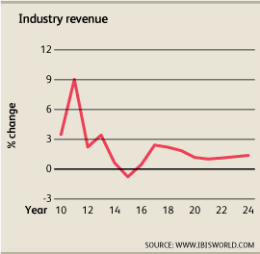
Over the five years to 2018, the Tourism industry experienced steady growth, as consumer spending, inbound trips by non-US residents and domestic trips by US residents all increased during the five-year period. The major sources of industry revenue include traveler accommodations (which are expected to account for 20.0% of industry revenue in 2018); transportation (41.3%); food and beverage services (14.1%); and recreation, entertainment and shopping (24.5%). These areas are all highly influenced by consumer spending trends. Over the past five years, travel spending increased in line with the overall healthy economy and increasing per capita disposable income levels, benefiting industry operators. However, heightened competition amid volatile commodity markets offset some of these gains, resulting in mixed growth early during the period. Nevertheless, the Tourism industry’s revenue is expected to increase at an annualized rate of 1.0% to $970.2 billion over the five years to 2018, including estimated growth of 2.2% in 2018 alone.
Travel trends
Over the five years to 2018, the number of domestic trips by US residents is expected to increase at an annualized rate of 3.5% to 778.1 million trips. With continuously improving technologies, US air travel is more affordable and safer than ever. Additionally, higher disposable incomes have made leisure travel possible for a growing number of Americans. The internet and new information systems have also enabled businesses to serve clients over larger areas. In recent years, the availability of affordable teleconferencing has threatened some areas of business travel, but this trend has not become pervasive enough to influence domestic flights drastically. As a result of higher domestic demand and more leniency on ticket prices, operators are expected to experience an uptick in profit over the five years to 2018. Therefore, in 2018, profit for the average industry operator is expected to reach 13.1%, representing an increase from 11.5% in 2013.
Inbound travel experienced slight volatility over the past five years, as the value of the US dollar increased early in the period, making travel within the United States relatively more expensive for foreign visitors. Families that would otherwise spend liberally on a trip overseas postponed such plans or choose to travel domestically, resulting in tempered growth for international tourist arrivals. While long-term visitation plans are typically immune to downturns, as they are the result of many months of planning and preparation, overall tourism spending may suffer as some international travelers will have a tighter budget than previously anticipated. Over the five years to 2018, the trade-weighted index, which measures the value of the US dollar to its major trading partners, increased at an annualized rate of 1.4%. Therefore, trips to the United States for foreign travelers became relatively more expensive than domestic trips or trips to other countries. As a result, operators have attempted to entice international visitors by offering deals when possible and encouraging consumers to travel to their establishments over others.
Nevertheless, despite year-over-year fluctuations, inbound trips by non-US residents are expected to grow at an annualized rate of 1.3% to 74.7 million trips over the five years to 2018. The increase in visitation has been the result of strong growth in visitor numbers from emerging economies, such as South Korea, Argentina and China, as well as developed economies that also experienced robust growth during the five-year period, such as Australia and the United Kingdom. Due to the health of these countries’ economies, visitors from such locales have not been as strongly affected by the rise in the value of the US dollar. As a result of the uptick in inbound and domestic travelers, operators expanded their footprint during the five-year period. Over the five years to 2018, the number of industry establishments is expected to increase at an annualized rate of 1.6% to 443,165 locations. This growth is largely due to expansion from tour operators and travel agencies, while airlines, both domestic and international, have been consolidating operations. To outfit these new locations, operators have increased their workforce, with the number of industry employees expected to increase at an annualized rate of 1.8% to 5.5 million workers over the five years to 2018.
Sensitivities
The strong growth in consumer confidence over the past five years and the ensuing increase in consumer spending have been major factors affecting the industry’s relatively positive performance during the five-year period. The overall decrease in the unemployment rate resulted in an increase in disposable income, enabling consumers to spend more liberally on luxuries, such as travel. As a result, the lower unemployment rate, in conjunction with higher consumer confidence, has positively affected domestic travel spending and domestic tourism spending as a whole. Over the five years to 2018, consumer spending is expected to grow at an annualized rate of 2.9%.
However, the industry continues to be particularly sensitive to macroeconomic factors or other large-scale issues, such as geopolitical instability and terrorism, which affect people’s willingness to travel. The Tourism industry also contends with significant competition for its share of household disposable income from technological change (e.g. internet and interactive cable TV) and from most other leisure and recreation activities, making the industry one of the least protected and most competitive in the world. Technology also directly affects the industry’s storefront component through the growing use and popularity of online travel booking systems, which can provide more affordable, zero-commission sales and can be used from a person’s home or workplace.
Increasing competition
The Tourism industry operates in an increasingly competitive market. In the globalized 21st century, the average American has a plethora of options regarding where to travel to and how much to spend on his or her vacation. Domestic vacations are now easily substituted with international travel, and there is stiff competition from a growing number of countries for a share of total global international travel. Countries in Central and South America, where economic conditions have improved significantly in the past decade, are now marketing themselves as convenient and safe travel locations for North Americans. The same can be said of nontraditional destinations in Eastern Europe, such as Turkey and Croatia. This competition has negatively affected the domestic Tourism industry, leading to slower long-term growth. Furthermore, due to the stronger dollar in comparison with the United States’ trading partners, a larger number of consumers have begun to take advantage of these cost savings, increasing the rate of international travel in turn. Over the five years to 2018, the number of international trips by US residents is expected to increase at an annualized rate of 2.5%. While this growth can be somewhat beneficial to airline operators, this trend has been detrimental to most domestic operators attempting to lure a larger number of consumers within a highly competitive market. This trend has resulted in severe price competition, offsetting many gains in input savings and consumer metrics such as increases in per capita disposable income.

Revenue Growth
Year | Revenue $ million | Growth %
2005 | 855,842.7 | 0.0
2006 | 884,605.3 | 3.4
2007 | 897,744.5 | 1.5
2008 | 885,643.5 | -1.4
2009 | 774,285.2 | -12.6
2010 | 801,267.2 | 3.5
2011 | 873,735.0 | 9.0
2012 | 893,237.6 | 2.2
2013 | 923,861.1 | 3.4
2014 | 929,836.9 | 0.6
2015 | 922,652.2 | -0.8
2016 | 926,796.8 | 0.4
2017 | 949,246.1 | 2.4
2018 | 970,224.7 | 2.2


Industry Outlook
Over the five years to 2023, the Tourism industry is forecast to experience greater growth and steadier revenue gains. While consumer confidence is projected to decrease over the next five years, inbound trips by non-US residents, domestic trips by US residents and consumer spending are forecast to increase, resulting in greater demand for industry services. Concurrently, the trade-weighted index (TWI), which measure the value of the US dollar compared with its major trading partners, is anticipated to decrease an annualized 0.2% over the next five years. As a result, travel to the United States will become relatively more affordable and, therefore, more enticing to foreign travelers. Therefore, over the five years to 2023, industry revenue is forecast to increase at an annualized rate of 1.3% to $1.0 trillion.
Travel trends
Over the next five years, the Tourism industry is expected to continue benefiting from the healthy domestic economy, stable unemployment rates and increasing consumer spending. Over the five years to 2023, consumer spending is projected to increase at an annualized rate of 1.9%. When consumers are willing to spend more money, they are also more willing to spend on discretionary purchases, such as travel. Changes in the relative price of domestic and international travel also play a large part in determining travel patterns. The price of gas feeds directly into travel costs such as airline tickets and auto-related travel. Other noneconomic factors include individuals’ and families’ available free time to travel, cultural and family links and the age of travelers. Though the world price of crude oil is expected to increase over the next five years, it is anticipated to do so at a far more stable rate than during the previous five-year period. Moreover, time spent on leisure and sports is forecast to increase an annualized 0.3% over the next five years. Therefore, over the five years to 2023, domestic travel is forecast to increase an annualized 1.6%.
The number of inbound visits to the United States is forecast to surge at an annualized rate of 3.6% over the five years to 2023, as continued growth in several emerging economies will enable more people to travel abroad. Unfortunately, European economies are forecast to stay flat or grow only marginally, hindering demand from this region, with the United Kingdom and Germany remaining the major sources of demand in this region. Similarly, travel from Canada is expected to decrease slightly, predominantly due to rising consumer debt and volatile commodity prices, which have dampened consumer sentiment. Instead, fledgling economies in East Asia and South America will drive growth. For example, Mexico, South Korea, China and Argentina have all experienced a spike in disposable income, spurring demand from leisure and business travelers.
Though consumers from advanced economies once dominated global tourist arrivals, the share of global arrivals between advanced economies and emerging economies is now fairly equal. Over the next five years, the Tourism industry will increasingly rely on travelers from emerging economies. Lastly, a changing political climate may also have a lasting effect on tourism over the next five years; any legislative changes pertaining to inbound travelers could dampen enthusiasm among many foreign tourists to visit the United States, dampening revenue growth in turn. Conversely, possible improvements in the country’s overall infrastructure could potentially benefit industry operators. As a result, operators must remain vigilant, offering deals when possible and encouraging consumers to travel to their establishments over others to maximize revenue growth.
Industry landscape
Over the next five years, merger and acquisition activity is anticipated to increase, especially among larger players absorbing smaller operators. However, the number of new operators entering the industry is forecast to outpace the consolidation activity, particularly the number of tour operators and travel agents. Over the five years to 2023, the number of industry operators is expected to increase at an annualized rate of 2.0% to 425,396 enterprises, due to an uptick in travel demand fueling overall growth. During the same five-year period, industry employment is expected to rise at an annualized rate of 1.2% to 5.9 million workers.
The most significant change over the next five years will be the continued move toward online bookings and reservations that offer relatively low-cost transactions, which are expected to grow strongly over the next five years. Major operators are expected to acquire global, regional and local websites to improve revenue and profit performance and capture a larger share of this growing area. This trend will result in a need for far fewer travel and customer service agents, as well as brick-and-mortar establishments, particularly independent ones, as online travel information, booking and payment increasingly become the norm for more and more travelers. While demand for industry services is expected to increase over the next five years, profit is not expected to fluctuate significantly. In fact, profit for the average industry operators is expected to remain stable at 13.1% over the next five years, as the world price of crude oil is expected to increase, leading airline operators to increase their ticket prices and offset the losses incurred by brick-and-mortar establishments. Since operators in the air travel segment make up the largest portion of the industry, fluctuations in purchase costs for them significantly influences the industry’s overall cost structure.
Additionally, over the next five years, there will be continuing fragmentation of the accommodations segment of the industry as travelers shift their preferences over time toward serviced apartments and other smaller, more hospitable locations. Apartment rentals and swaps are another growing segment within the industry as travelers seek to trim their accommodation budgets to spend more on entertainment. The progressive aging of the population may lead to increased demand for newer forms of purpose-built accommodations for a longer stay, as well as new RV parks, in major tourist regions.
Revenue Outlook
Year | Revenue $ million | Growth %
2019 | 988,259.6 | 1.9
2020 | 999,953.7 | 1.2
2021 | 1,010,166.1 | 1.0
2022 | 1,021,512.8 | 1.1
2023 | 1,034,304.3 | 1.3
2024 | 1,048,634.2 | 1.4
Back to top

Industry Life Cycle
This industry is mature More Info
The Tourism industry exhibits the traits characteristic of an industry in the mature stage of its life cycle. Over the 10 years to 2023, industry value added (IVA), which measures an industry's contribution to the overall economy, is forecast to increase at an annualized rate of 2.0%. Comparatively, US GDP is anticipated to increase at an annualized rate of 2.1% during the same period. IVA growth that is slightly slower or closely mirrors GDP growth is indicative of an industry in the mature stage of its life cycle. Moreover, the industry has experience little technological change, with operators. mostly focusing on improving efficiency rather than introducing new technologies, and major players have been increasing their market share through merger and acquisition activity, rather than organic growth. The Tourism industry has also experienced several challenges in recent years, such as circumstances that increased geopolitical tensions and made travelers wary of air travel, resulting in volatile IVA growth.
An industry with IVA growth slightly slower than the overall GDP is a strong indication of a mature industry. Additionally, demand from the domestic market is growing at a similar rate as that of the international segment. Over the 10 years to 2023, the number of domestic trips Americans take is expected to grow at an annualized rate of 2.6% to 844.3 million, compared with a growth rate of 2.4% of inbound international visitor arrivals during the same period. The growth of the inbound international segment shows that future industry growth will increasingly correspond with rising global income, particularly in countries in Asia and South America. However, domestic travel still accounts for the lion's share of the industry's revenue and is expected to do so for some time. Increasing incomes and the aging of the population are also expected to drive growth in the domestic market.

